

The Kansas Association of Local Health Departments, the Kansas School Nurses Organization, and the Immunize Kansas Coalition are teaming up to remind you why routine vaccines for school entry are necessary and a cost-effective life-saving measure for your child.

**Routine vaccines keep everyone healthy.**

Children who are not vaccinated according to both the Kansas requirements and the Centers for Disease Control and Prevention (CDC) are at higher risk of getting diseases that could really make them sick. Diseases such as measles and polio can cause life-altering side effects like permanent paralysis. Not vaccinating your child can not only make THEM sick, but it can also make other children sick, too. Disease spreads quickly among children, and children who have weakened immune systems can be severely at-risk for catching diseases. Vaccinating keeps everyone healthy and students in school where they can learn.

**Routine vaccines allow children to have better immunity to disease over time.**

Prior to routine vaccines, children had high rates of death in the United States. According to the National Bureau of Economic Research, about 1 in 5 children died before the age of 5, with a leading cause being vaccine-preventable diseases. With vaccines, children can build better immunity to diseases over time, increasing their lifespan and giving parents peace of mind that their children are safe from disease. Vaccines work by training your body to fight germs faster. Vaccines teach the body what germs to look out for, and the body naturally builds up a supply of antibodies to target the specific germ and fight the disease when it encounters it. Vaccines encourage the body to build up its immunity – and that’s a good thing.

**Routine vaccines are designed by top doctors, public health professionals, and scientists.**

Before vaccines are made available to the public, they go through a thorough clinical and design process, where every component of the vaccine is tested to ensure safety and effectiveness. All vaccine manufacturers are required to put vaccines through a long process known as a clinical trial. This trial typically occurs in 3 phases and any adverse reactions that occur during the process are reviewed to guarantee safety and determine if the vaccine needs more research and trials.

**The danger of not following the vaccine schedule and delaying vaccination.**

Following the recommended schedule published by the CDC and the school requirements for Kansas is important for the immunization process to work at its best. Along with testing for safety, vaccine manufacturers test at different time periods for effectiveness, determining the best time to give the vaccine to increase the immune response. Delaying those vaccinations can cause the vaccines to lose their effectiveness and expose your child to diseases they could have otherwise avoided.

**Immunizations needed to attend Kansas public schools.**

Per state law, prior to attending school, all students must present certification that they are up to date on their immunizations. Failure to receive all required vaccinations shall be deemed noncompliance. Any student who does not provide documentation of vaccinations, or a legal exemption may be excluded from school per their school district’s policy. Keeping your child up to date on routine vaccines can prevent them from missing valuable class time.

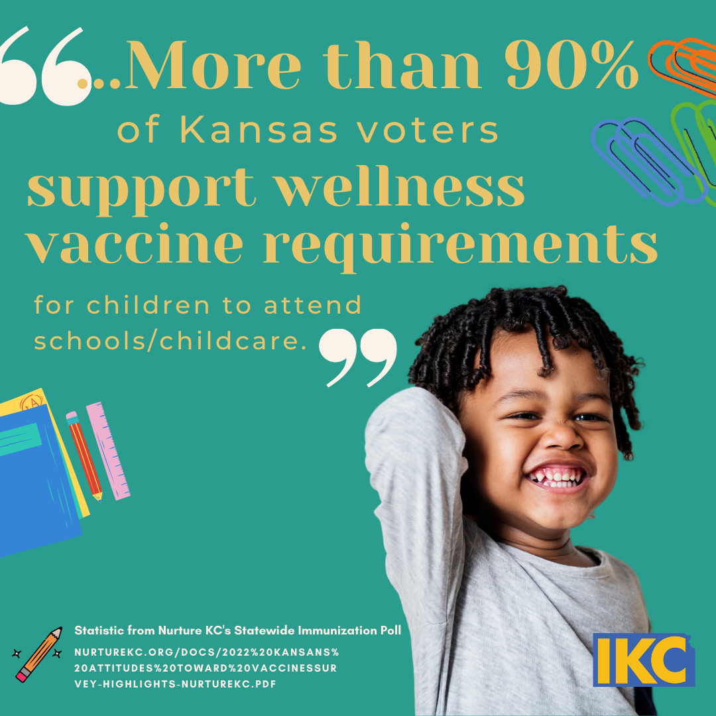Maintaining school immunization requirements ensures that Kansas schools and their students remain protected from vaccine-preventable diseases. Together, we can do our part by keeping school immunization requirements in place, building widespread community immunity for years to come.

Contact:

Kansas Association of Local Health Departments

[Shelby.ostrom@kalhd.org](mailto:Shelby.ostrom@kalhd.org)

Kansas School Nurses Organization

<https://www.ksno.org/contactus>

Immunize Kansas Coalition

[staff@immunizekansascoalition.org](mailto:staff@immunizekansascoalition.org)