LHD Business Hours Recommendations

Most LHDs in Kansas (50%) have 8 a.m. to 5 p.m. as their regular, public business hours all week. Some LHDs open at 7 to 7:30 a.m. (12%). The other 38% LHD respondents have various hours all week, and out of those 38%, 4 of them close at 6 p.m.

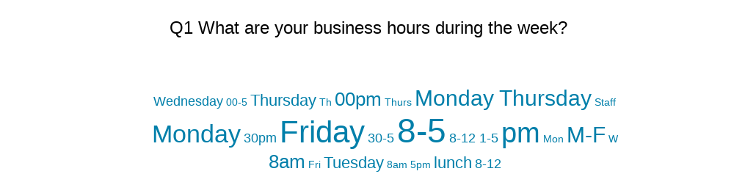

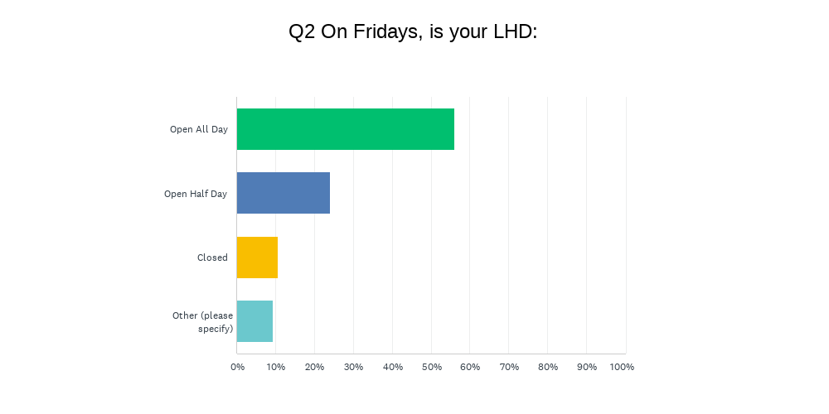56% of LHDs are open all day on Friday. Some LHDs close at noon on Friday (18%) and 10% are closed all day on Fridays.

To be considered for “full time” employment, employees must work for 38 to 40 hours at most LHDs (40%). Many other LHDs use 32-35 hours as “full time” (20%) Full time employment at all LHDs includes benefits such as sick leave/vacation, and insurance.

The average sick/vacation time accrued for LHDs is 4 hours every two weeks (26%). However, many LHDs have various methods to get there (Individual Responses examples in Figure 1 below)