Typhoid Fever
Research provided by the Kansas Association of Local Health Departments

What is it?
Typhoid Fever is a life-threatening infection called by the Salmonella Typhi bacteria (within the same family as salmonella typically found in food). It can be spread through contaminated water or food and through person-to-person contact. Both people who contract the disease and have active infections, can spread the disease through their poop. When the bacteria enter the body, it multiplies and spreads into the bloodstream. Typhoid Fever typically causes a sustained, dangerously high fever of 103 to 104 and include symptoms such as diarrhea, stomach pain, cough, weakness, and a rash of flat, rose-colored spots. Typhoid Fever is typically treated by antibiotics. If not treated in time, the infection can spread throughout the body for months and cause severe complications or death.
Paratyphoid Fever
Paratyphoid Fever is a variant of Typhoid Fever caused by the Salmonella Paratyphi bacteria. The bacteria cause similar symptoms to Typhoid Fever and is just as deadly if not treated. There is currently no vaccine available for Paratyphoid Fever.
History
The history of Typhoid Fever is well documented. In ancient Greece a plague believed to be Typhoid killed one-third of the population of Athens. By the 17th century, it is believed that Typhoid Fever was responsible for the death of the Jamestown, Virginia colony (yes, the Pocahontas/John Smith group). In addition, recent reports indicate that William Henry Harrison, the 90-day president, died of Typhoid Fever rather than pneumonia, and Zachary Taylor later. Throughout the 19th century, Typhoid Fever was the leading cause of death for both soldiers and civilians during the Civil War. Typhoid Fever continued to be a problem until vaccines became widely available.
“Typhoid Mary” Mallon
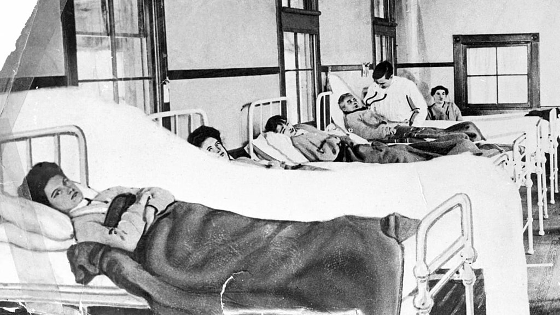
You may have heard a story or two about Mary Mallon, or as she is now known as “Typhoid Mary”. Mary Mallon was an Irish immigrant who lived in New York during the early 1900s. Mallon worked as a domestic servant and cook for wealthy families across New York during that time. However, from 1900 to 1907 over 24 people fell ill with Typhoid Fever in New York City and Long Island when Mallon was working as a servant for wealthy families. It was later learned that Mallon was a carrier of the Salmonella Typhi bacteria and would give it to others without knowing. However, it was later revealed that Mary knew she was a carrier and would disappear when people started to get infected. In 1906, a New York Department of Health worker George Soper investigated an outbreak in Long Island and determined that Mallon was the cause. Soper and authorities eventually found the fleeing Mary and committed her to isolation on North Brother Island.
The term “Typhoid Mary” is now used for someone who spreads disease or undesirable opinions, sentiments, or attitudes.
Vaccine Development – Are You Team Wright or Team Pfeiffer?
Historians credit British pathologist Almroth Wright and German bacteriologist Richard Pfeiffer with developing the first Typhoid Fever vaccine in 1896. The British Army had commissioned Wright to develop the vaccine in 1895. There is still a continued battle over who published their work first.
Current Vaccines
The United States has two available vaccines for Typhoid Fever. The vaccines or “pills” can be taken two weeks prior to traveling outside of the country. In 2018 the WHO recommended the conjugate vaccine and can be given to children as young at 6 months and offers longer immunity.
As expected, Typhoid Fever spreads in areas with little sanitation and dirty water. With many countries having these problems, the United States recommends a Typhoid Fever vaccine before traveling.
What Can We Learn?
Typhoid Fever is an interesting case, particularly because it isn’t given to children, but is a travel vaccine, so many Americans do not receive a vaccine and are at an increased risk of contracting Typhoid Fever. We can also learn about how quickly bad bacteria can severely impact healthy individuals and having sanitation and protections are important.
Sources and Further Reading:
https://www.passporthealthglobal.com/2021/12/the-history-of-the-typhoid-fever-vaccine/]
https://www.britannica.com/biography/Typhoid-Mary
https://pubmed.ncbi.nlm.nih.gov/33726955/
https://pubmed.ncbi.nlm.nih.gov/27083427/
https://www.cdc.gov/typhoid-fever/symptoms.html
https://www.cdc.gov/typhoid-fever/sources.html
https://www.cdc.gov/vaccines/vpd/typhoid/hcp/index.html

