Rubella

*Research provided by the Kansas Association of Local Health Departments*

**What Is It?**

Rubella, also known as German Measles, is a viral disease that is spread through coughing and sneezing. An infected person can spread the disease for up to 7 days before symptoms start. Rubella produces mild flu-like symptoms for most people, which includes a rash that starts on the face and can travel across the body and mild pink eye. Rubella is typically the most dangerous for pregnant women.

**Congenital Rubella Syndrome (CRS)**

Like Mumps, a woman who is infected with Rubella can miscarry, or spread dangerous side effects to her child including heart problems, intellectual and physical disabilities, and organ damage. These side effects are more common early in pregnancy, and a birth defects by Rubella in utero are called Congenital Rubella Syndrome. Like Chicken Pox, once infected, a person develops lifelong immunity to Rubella. [You can read more about CRS and living with it here.](https://measlesrubellainitiative.org/living-with-congenital-rubella-syndrome-you-get-called-stupid-or-slow-you-arent-im-not/)

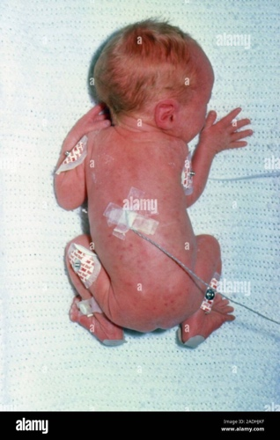

**History**

The term Rubella was translated from the German word Röteln as early as 1619, when German physician Daniel Sennert first discovered the disease. It was distinguished from Measles in the early 19th century and continues to be called German Measles because of its prevalence in Germany. Because the disease does not typically cause long-term side effects, it was not studied to the same extent as Measles. However, in 1941, Australian OBGYN McAlister Gregg discovered that Rubella was responsible for prenatal infections that caused congenital malformations in children.

**Vaccination & Eradication in the United States**

Because Rubella can cause serious birth defects, during the last endemic in the United States from 1964 to 1965, over 11,000 pregnant women lost their babies and over 20,000 babies were born with Congenital Rubella Syndrome. A vaccine was made available in the United States in 1969 and was later concentrated to the childhood MMR vaccination. The United States began a nationwide eradication effort of Rubella that ended in 2015 when it was declared that the Americas were free of endemic Rubella transmission.

**The Andrew Wakefield Study**

As mentioned during Measles week, then Dr. Andrew Wakefield developed a study where he wrongfully determined that symptoms of Autism and IBS were present in children who had received the MMR vaccination. Originally published in *The Lancet,*it incorrectly linked 12 children’s symptoms to vaccines. However, it was later revealed that Dr. Wakefield had ethical and financial ties to a competing Measles vaccine provider in the United Kingdom. After the study was released and then debunked, the vaccine rate from the MMR fell from 95% to 80% in the early 2000s in the UK.



Andrew Wakefield continues to be used as an example of bad epidemiological and research study, with books, articles, and conversations being had on what not to do. However, for the anti-vaccine movement, which has slowly been gaining traction since the 1970s, he is hailed as a hero.

***What We Can Learn from the MMR***

Once hailed as an innovation in combination vaccines, the MMR has experienced a lot of media attention, but many people are not fully aware of the diseases that the vaccine prevents. Because of Andrew Wakefield’s study, deadly diseases for children and pregnant women have become prevalent in world again, causing small, pocket outbreaks to occur in areas of low vaccine confidence. By learning the side effects of the diseases, the MMR is intended to protect from, we can remove fear from science, which is one of the leading reasons for vaccine skeptics. [*Nature*released an article about Andrew Wakefield that sheds light on how he was able to fool the world.](https://www.nature.com/articles/d41586-020-02989-9) As public health professionals, we can take the power back.

Sources & Further Reading:

<https://www.cdc.gov/rubella/about/complications.html>

<https://www.cdc.gov/rubella/about/symptoms.html>

<https://www.cdc.gov/rubella/about/in-the-us.html>

<https://measlesrubellainitiative.org/living-with-congenital-rubella-syndrome-you-get-called-stupid-or-slow-you-arent-im-not/>

<https://www.britannica.com/science/rubella>