Meningitis

*Research provided by the Kansas Association of Local Health Departments*

This week we will be discussing meningitis. Meningitis is a disease that is very deadly, but many people are not vaccinated. Kansas ranks in the lower half of meningitis vaccination. In 2017, only 75% of the state’s teens were vaccinated.

***What is It?***

Meningitis is a viral or bacterial disease that causes swelling of the brain and spinal cord. Excess fluid and “meninges” (membranes) build up in both areas, causing inflammation that can lead to symptoms like headache, fever, and a stiff neck. The most common type of meningitis comes from a viral infection; however, bacterial and fungal infections also happen. Bacterial infections are typically caused by untreated sinus or ear infections. Viral meningitis is typically mild; however, it can come from HIV, mumps, or West Nile virus. Viral meningitis is typically spread through kissing, sharing drinks, and sneezing. More severe symptoms of the infection can cause sepsis, which is a blood infection.

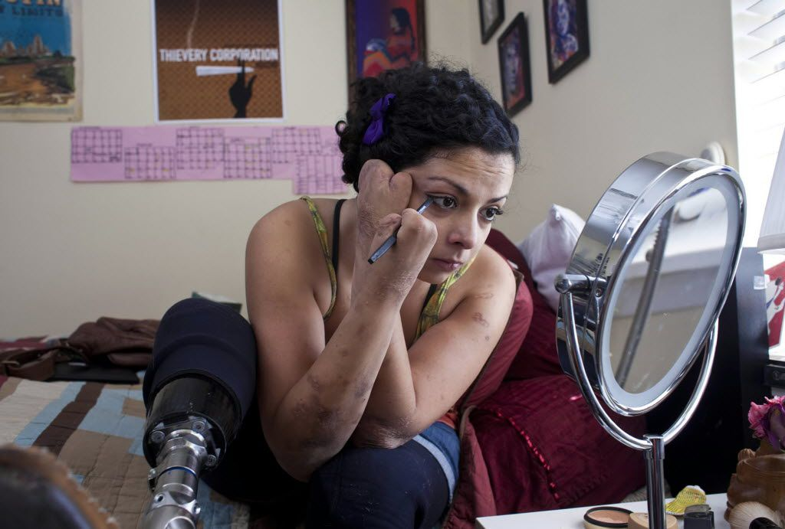

***History & Treatment***

This first meningitis outbreak happened in 1805 in Geneva. With the epidemic spreading to other continents like Africa by 1840. In 1887, Austrian bacteriologist Anton Vaykselbaum determined that meningitis came from a bacterial infection. By the 19th century, more symptoms to meningitis were discovered, these signs were called Kernig’s and Brudzinski signs, respectively. As of today, 70% of meningitis cases in the United State occur in children under 5 and those over 60 years old. About 4,000 people get bacterial meningitis in the United States.

Treatment for both viral and bacterial meningitis include antibiotics and oxygen therapy.

Even with rapid treatment, 10 to 15 out of 100 people will die. 1 in 5 people who survive will lose function in their limbs or have their limbs amputated.

***Vaccination***

There are five meningitis vaccinations available for teens and young adults in the United States that cover both bacterial meningitis and viral meningitis. Three vaccines protect from ACWY serogroups, and two vaccines protect from B. All these vaccines are approved for those 11 years and older. Because of the vaccines, rates of meningitis have decreased since the 1990s. However, uptick for these vaccines has been difficult to manage, particularly with vaccine hesitant communities and continues to be a topic of contention.

***2019 Kansas Legislature Addition that Caused Controversy***

Because Kansas ranked low in meningitis vaccine acceptance, [then KDHE Secretary Lee Norman added both the MenACWY and MenB vaccines to the adolescent schedule in 2019.](https://www.kshb.com/news/local-news/kdhe-now-requires-meningitis-hepatitis-a-vaccines-for-school-age-children) However, the Kansas Anti-Vaccine group pushed back on this addition. They claimed that this vaccine should not be a requirement and were angry that the vaccine was added after the 2019 legislative session. Many contribute this “controversy” to the reason that the legislature is continuing to fight for control of vaccines. As of 2022, both MenACWY and MenB are still on the schedule and required for all Kansas college students.

***Slow and Steady Wins the Race***

As mentioned above, Kansas still ranks low in meningitis vaccination acceptance. Various organizations in Kansas such as KDHE and Immunize Kansas Coalition have pledged to increase meningitis vaccination in Kansas through public information campaigns and resources. For more information or to get involved, you can check out the resources below.

[Immunize Kansas Coalition Meningitis Landing Page](https://www.immunizekansascoalition.org/meningitis-toolkit.asp)

[National Meningitis Association](https://nmaus.org/meningococcal-disease/#resources)

[National Foundation for Infectious Diseases – Meningitis](https://www.nfid.org/toolkits/meningococcal-disease-college-toolkit/)

***What We Can Learn***

There is a lot we can learn from meningitis and meningitis vaccination.  Lifelong Kansas resident Andy Marso contracted bacterial meningitis when he was a 22-year-old student at the University of Kansas in 2004. Andy was treated quickly, but he had blood poisoning from the infection that causes him to lose various limbs and functions in his legs. He had not been vaccinated, since KU did not require meningitis vaccinations to live in the dorms. After 2004 and Marso’s advocacy, all public universities in Kansas require meningitis vaccination for students. [You can read more about Andy’s story here.](https://www.khi.org/news/article/kansas-reporter-tells-tale-behind-life-and-death-f)

Sources & Further Reading:

<https://www.nfid.org/toolkits/meningococcal-disease-college-toolkit/>

<https://www.immunizekansascoalition.org/meningitis-toolkit.asp>

<https://nmaus.org/meningococcal-disease/#resources>

<https://www.immunizekansascoalition.org/documents/menresources/Meningococcal%20Provider%20Vaccine%20Document%2010.28.20.pdf>

<https://www.khi.org/news/article/kansas-reporter-tells-tale-behind-life-and-death-f>

<https://nmaus.org/meningococcal-disease/#resources\>

<https://www.immunizekansascoalition.org/documents/menresources/What%20is%20Meningococcal%20Disease%2010.27.20.pdf>

<https://www.mayoclinic.org/diseases-conditions/meningitis/symptoms-causes/syc-20350508>

<https://apnews.com/article/d8aa5858a541444e890f9b7457e851cb>

<https://meningitisbymumford.weebly.com/prevention--treatment.html>

<https://www.cdc.gov/vaccines/vpd/mening/public/index.html>

<https://dmn-dallas-news-prod.cdn.arcpublishing.com/resizer/_d6CXPINM8FHZDNXNecnhSgkoh8=/1660x934/smart/filters:no_upscale()/arc-anglerfish-arc2-prod-dmn.s3.amazonaws.com/public/DVRV4Z454B6VWX637J2WMWIDWU.jpg>