Chickenpox

*Research provided by the Kansas Association of Local Health Departments*

***What Is It?***

Chickenpox is a very contagious disease caused by the varicella-zoster virus. Like Smallpox, it causes blister-like rashes all over the body including the chest, back, and face. When Chickenpox has run its course in the body, it can cause between 250 and 500 blisters. While most children get Chickenpox and have mild symptoms, the virus can cause complications and severe illness, especially in those with weakened immune systems and young adults. Complications can include soft tissue infections, encephalitis, pneumonia, and sepsis. Chickenpox typically infects a person once and makes them immune. However, the virus remains in the body and can cause Shingles.

***Shingles***

Like Chickenpox, Shingles can cause painful blisters on different parts of the body. However, it typically only appears in one place. Shingles is caused by the same virus as Chickenpox, but it typically will live in nerve tissue after original Chickenpox infection and can appear at any time. Shingles is typically non-life-threating, they can cause lifelong nerve damage.

***History***

Originally discovered in 1767 by Dr. William Heberden, the varicella virus was differentiated from the smallpox virus and linked to the herpes zoster virus. It wasn’t until 1888 that Shingles and Chickenpox were connected after a study was done with children who were exposed to Shingles but not Chickenpox. Chickenpox, due to it being very infectious, traveled throughout the world. However, in 1951, the CDC in the United States didn’t believe that Chickenpox was a significant enough disease to include in disease reporting measures. It wouldn’t become a member of the disease reporting list until 1972, when 164,114 cases were reported during the year. Throughout the next century, Chickenpox became a rite of passage for children in the United States. Parents were encouraged to expose their children to Chickenpox early to avoid infection as an adult.

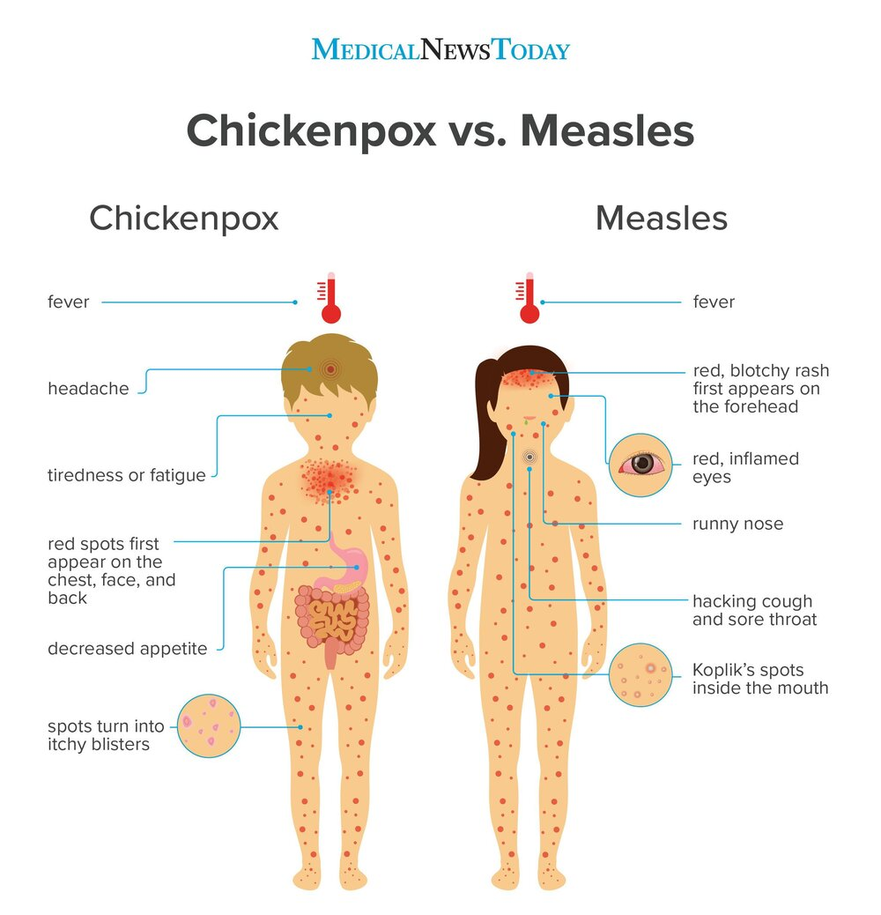

***Reye Syndrome***

In the 1970s, the CDC became aware of a condition called Reye Syndrome. This syndrome can affect the liver, blood, and brain, which can lead to death. While Reye Syndrome is rare, it was determined that the use of aspirin as a fever reducer for children with Chickenpox or Influenza could cause Reye Syndrome. In 1982, the Surgeon General issued a warning on aspirin that is still in use today.

***Vaccination for both Chickenpox and Shingles***

In 1996, the ACIP recommended a Chickenpox vaccination for children starting at 1 year old with a booster dose from 4-6 years old prior to entering school. While breakthrough infections continued to occur, children vaccinated were less likely to spread the disease. Additionally, the age of disease onset occurred, moving from young children to 9 to 11 years old. There is also a licensed MMRV vaccine that prevents Measles, Mumps, Rubella, and Chickenpox (varicella).

In 2008, the ACIP moved forward with approving a Shingles vaccination for adults 60 years and older to mitigate the appearance of Shingles. In 2018, Shingrix was introduced to the market for anyone older than 50. It boasts a 96% effectiveness rate.

***Personal Connections from Your “Resident” Millennial (Or Gen Z depending on who you ask)***

I was born in February 1995, one year prior to the licensing of the Chickenpox vaccine. I was a part of the first group of children to get the vaccine and the booster dose when I was 4. While I don’t remember the vaccination, two of my classmates in second grade (who had also received the vaccine) both got chickenpox from each other in 2002. In 2004, my brother, who had also received both the primary and booster doses of the vaccine got Shingles on his face. It cleared up quickly and thankfully has not caused any nerve damage. ***Consequently, unlike many of you, I have never had Chickenpox. The vaccine worked for me.***

***What We Can Learn***

Like Measles, Chickenpox was a rite of passage for children in the United States. However, due to vaccination, we can prevent Chickenpox side effects like Shingles from getting worse and causing death. While many claim that natural immunity is most effective, vaccinations protect those who cannot get natural immunity because of immunocompromising conditions. Vaccines allow us to live longer and healthier, and it many cases, fully eradicate diseases.

Sources & Further Reading:

<https://ftp.historyofvaccines.org/content/articles/shingles-herpes-zoster>

<https://www.nvic.org/vaccines-and-diseases/chickenpox/history.aspx>

<https://www.mayoclinic.org/diseases-conditions/shingles/symptoms-causes/syc-20353054>

<https://www.cdc.gov/chickenpox/about/complications.html>

<https://www.cdc.gov/chickenpox/about/symptoms.html>

<https://www.cdc.gov/chickenpox/about/index.html#:~:text=Chickenpox%20is%20a%20highly%20contagious,250%20and%20500%20itchy%20blisters>.

<https://kidshealth.org/en/parents/chicken-pox.html>

<https://mapleleafmedical.com.au/blog/2019/9/20/chickenpox-vs-measles-whats-the-difference>