NAMEHERE Health Department: Quick Facts
Here in COUNTYNAME County the local health department provides numerous services to area residents. Some services are mandated by state law and some are selected to improve the quality of life.
What is Public Health?
The efforts, science, art, and approaches used by all sectors of society to assure, maintain, protect, promote, and improve the health of people.
Public Health:
Focuses on prevention
Environmental health
Administers programs & services to reduce chronic disease
Improves health outcomes
Engages community partners to monitor & assess the health of the community
Develops and implements public health policy

Local Public Health Powers Include:
Receiving reports of diseases
Investigating causes of diseases & cases of infectious/contagious disease
Preventing the spread of disease
Ordering persons to seek appropriate & necessary evaluation & treatment
Using isolation & quarantine measures when required

Some services we directly provide:
- Insert specifics in this list. You can refer to a map of services constructed from the 2019 State Formula survey at: https://kphcollaborative.org/interactive-map/ (recommended list length: 5 items)
- Chronic Disease Prevention
- Injury Prevention
- Preparedness
- Disease Investigation
Our department also works with other community partners to ensure a vast array of health services exist. One key tenet of public health is about ensuring access to services, be they provided by our department or by another provider.
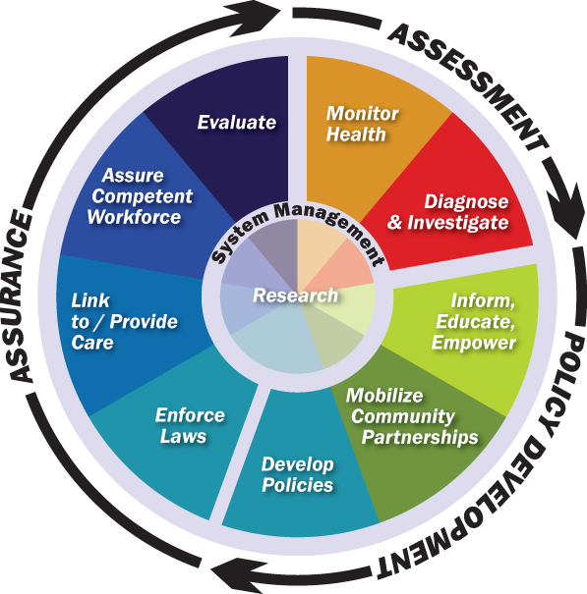

Public health is an evolving system. Modernization efforts are underway to further the quality of life for Kansans.
State Formula funding is a core part of keeping the public health system functional. According to KDHE there has been no increase since 1992 despite inflation and a growing Kansas population. Meaning we now are doing more than ever with resources not keeping pace. Local public health needs additional State support to achieve its mission!
Here are some key health indicators we are working to address in COUNTYNAME County
(Insert two relevant graphs from http://www.kansashealthmatters.org/index.php?module=indicators&controller=index&action=dashboard&alias=counties)
